

Problem Solving and
Programming
MODULE 1

MODULE-I

Fundamentals of Programming and Programming Logic
The History of Python, Getting Started with Python, Flowchart, Algorithm, Programming Style, Programming Errors.
Input from the Console, Identifiers, Variables, Constants, Data Types and Operators, Assignment Statements and Expressions, Evaluating Expressions and Operator Precedence, Type Conversions and Rounding.

FUNDAMENTALS OF PROGRAMMING AND PROGRAMMING LOGIC
Fundamentals of Programming and Programming Logic means the basic building blocks you need to start writing computer programs and the thinking process (logic) behind solving problems step by step.
- Programming Fundamentals → learning the basics of a programming language (like Python), such as variables, data types, operators, input/output, etc.
- Programming Logic → learning how to think logically to solve a problem, like writing steps in order, using flowcharts, algorithms, and conditions (if/else), loops, etc.

INTRODUCTION TO PROGRAMMING LANGUAGE
What is a Programming Language?
A programming language is a way for humans to communicate with a computer.
- Just like we use English, Hindi or Telugu to talk to people.
- We use programming languages (like Python, C, Java) to give instructions to computers.
- These instructions are written in the form of a program.
A programming language is a tool to tell the computer what to do. It acts as a bridge between humans and machines.

PROBLEM SOLVING
What is Problem Solving?
Problem solving is the process of finding solutions to difficult or complex issues. In programming, we solve problems by writing code that a computer can understand and execute.
Steps in Problem Solving:
- Understand the problem – What is being asked?
- Plan a solution – Decide how you’ll solve it.
- Write the code – Use Python to write the solution.
- Test the code – Run it to see if it works correctly.
- Debug – Fix any mistakes (errors or bugs).

HISTORY OF PYTHON
- Created by Guido van Rossum in the late 1980s.
- First released in 1991.
- Named after the comedy show "Monty Python’s Flying Circus" (not the snake!).
- Designed to be simple, readable, and powerful.

FEATURES OF PYTHON
These are the special qualities that make Python popular:
- Easy to learn – its code looks like English.
- Interpreted – you can run it directly, no need to compile.
- Portable – works on Windows, Mac, Linux, etc.
- Free & Open Source – anyone can use and improve it.
- Large Libraries – ready-made code for math, AI, web, data, etc.
- Object-Oriented – supports classes and objects.
Features = why Python is special.

APPLICATIONS OF PYTHON
These are the areas where Python is used:
- Artificial Intelligence & Machine Learning
- Data Science & Data Analysis
- Web Development (websites, apps)
- Mobile Apps & Games
- Scientific & Mathematical Computing
- Automation / Scripting (doing repeated tasks automatically)
Applications = where Python is used.

GETTING STARTED WITH PYTHON
To write and run Python code, you need:
Python installed on your computer (download from python.org)
A code editor or IDE (e.g., IDLE, VS Code, Jupyter Notebook),
IDE- Integrated Development Environment
Example Python Code:
print("Hello, world!")
This print Hello,world! on the screen

Same Hello, world program in C
#include <stdio.h>
int main() {
// Print Hello, World! to the screen
printf("Hello, World!\n");
return 0;
}
Output- Hello,World!

Same Hello, world program in Java
public class HelloWorld {
public static void main(String[] args) {
// Print Hello, World! to the console
System.out.println("Hello, World!");
}
}
Output- Hello,World!

FLOWCHART
What is a Flow Chart?
- A flowchart is a picture (diagram) that shows the steps of a program or process using symbols and arrows.
- It helps us plan and understand a program before writing code.
Symbols of Flowcharts
- 🔵 Oval (Ellipse) → Start / End
- ⬛ Parallelogram → Input / Output (read or print data)
- 🟦 Rectangle → Process (do some calculation or task)
- 🔷 Diamond → Decision (Yes/No, True/False)
- ⚪ Circle / Connector → Connect different parts of a flowchart
Sum of two numbers
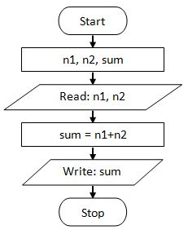
1. Start
- Symbol: Oval
- Description: This indicates the beginning of the program or process.
2. Input A
- Symbol: Parallelogram (Input/Output)
- Description: The first number (let's call it A) is entered by the user or provided as input.
3. Input B
- Symbol: Parallelogram (Input/Output)
- Description: The second number (let's call it B) is entered by the user or provided as input.
4. C = A + B
- Symbol: Rectangle (Process)
- Description: The addition operation is performed, and the sum of A and B is stored in a variable called C.
5. Output C
- Symbol: Parallelogram (Input/Output)
- Description: The calculated sum (C) is displayed or printed as the result.
6. End
- Symbol: Oval (Terminator)
- Description: This indicates the end of the program or process.

ALGORITHMS
An algorithm is the logic of a program written as step-by-step instructions to solve a problem.
- Characteristics
  - Each step must be clear and precise.
  - No step should run forever.
  - Must produce the correct result.
- Advantages
  - Easy to understand (step-by-step).
  - Has a definite procedure.
  - Works with any programming language.
  - Easy to debug because each step is separate.
- Disadvantages
  - Time-consuming to prepare.
  - Hard to show branches (decisions) and loops in plain text.
Example 1: Print “Good Morning”
- Step 1: Start
- Step 2: Print "Good Morning"
- Step 3: Stop
Example 2 : Write an algorithm to find area of a rectangle.
- Step 1: Start
- Step 2: Take length and breadth and store them as L and B?
- Step 3: Multiply by L and B and store it in area
- Step 4: Print area Step 5: Stop

PROGRAMMING STYLE AND ERRORS
Good programmers follow a clean style:
- Use proper indentation (spaces before code).
- Write comments to explain the code.
Example:
# This is a comment
name = "Ashish" # Storing a name in a variable
print(name)
Output- Ashish

Indentation means adding spaces or tabs at the beginning of a line of code to show which lines belong together. It helps in organizing the code and showing structure especially in Python, where indentation is not optional but required.
In simple word - Indentation is how we tell Python which code is inside a block (like inside an if, for, while, or a function).
Example with indentation
if 5 > 2:
print("Five is greater than two!")
# Error! No indentation
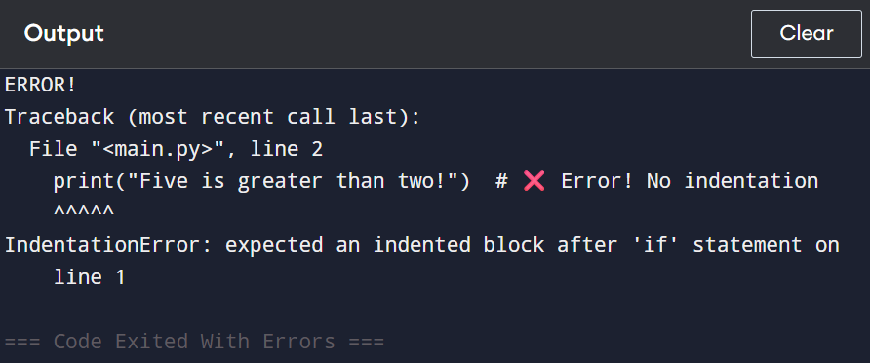

Example without indentation
if 5 > 2:
print("Five is greater than two!") # Indented correctly
Here, the print() line is indented (usually 4 spaces or 1 tab), so Python knows it belongs inside the if block.

PROGRAMMING ERRORS
There are 3 types of errors:
1. Syntax Error – Mistakes in the code structure (like forgetting a colon)
if x == 10 # Missing colon
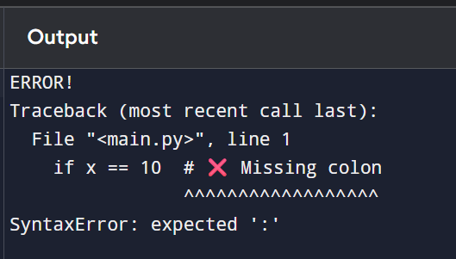
2. Runtime Error – Happens when code runs (like dividing by 0).
print(5 / 0) # Error at runtime
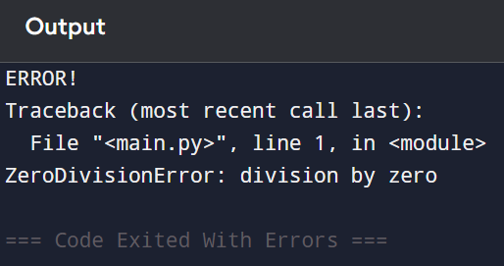

3. Logical Error – Code runs, but gives wrong output.
print(2 + 2) # But logic was to multiply
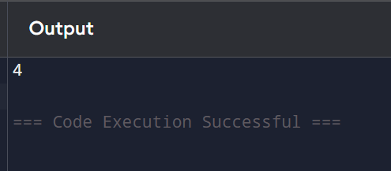

Type of Error | Code Runs? | Output Correct? | Example
Syntax Error | No | ❌ | print("Hello) → missing quote
Runtime Error | No | ❌ | print(1 / 0) → division by zero
Logical Error | Yes | ✅,❌ | print(2 + 2) when you meant 2 * 2

INPUT FROM THE CONSOLE
To get input from the user:
name = input("Enter your name: ")
print("Hello", name)
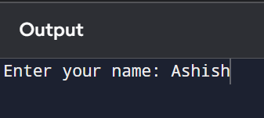
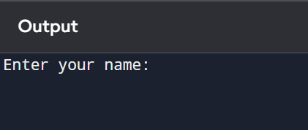
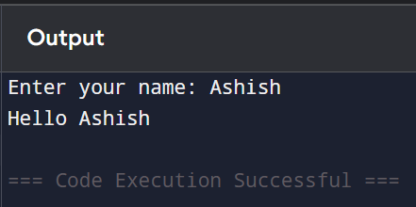

IDENTIFIERS, VARIABLES & CONSTANTS
IDENTIFIERS
- Identifiers: Names used to identify variables, functions, etc.
Example: name, age, totalMarks
- Variables: Store data.
x=10
Identifiers are the names used to identify variables, functions, classes, modules, etc.
Rules for Naming Identifiers:
- Can contain letters (a-z, A-Z), digits (0–9), and underscores (_)
- Cannot start with a digit
- Cannot use Python keywords like if, else, while, class, etc.
- Python is case-sensitive: Age, age, and AGE are different identifiers.
Examples
- name = "John" # valid
- age1 = 25 # valid
- _name = "Ashish" # valid
- 1age = 30 # Invalid: starts with a digit
- def = 10 # Invalid: 'def' is a keyword
VARIABLES
A variable is a container or label that stores data. You can think of it like a box where you keep something.
Variable Features: You don’t need to declare the data type. Python automatically understands it.
You can change the value or data type at any time.
Example
x = 10 # x is a variable holding an integer
name = "Alice" # name is a variable holding a string
x = "hello" # x is now a string (changed type)
CONSTANTS
- A constant is a value that does not change.
- Python doesn't have true constants.
PI = 3.14

DATA TYPES
- int – Whole numbers (10, -5)
- float – Decimal numbers (3.14)
- str – Strings/text ("Ashish")
- bool – True or False
OPERATORS
- Arithmetic: +, -, *, /, %, //, **
- Comparison: ==, !=, >, <, >=, <=
- Logical: and, or, not

ASSIGNMENT STATEMENTS AND EXPRESSION
- Assignment Statement: Assign value to a variable.
age = 20
- Expression: A combination of values and operators
total = 5 + 3

ASSIGNMENT STATEMENTS
An assignment statement is how you store a value into a variable using the = operator.
Examples
a = 5 # Assigning integer
b = "Python" # Assigning string
c = 3.14 # Assigning float
You can also assign multiple variables at once:
x, y, z = 1, 2, 3 # Multiple assignments

EXPRESSIONS
An expression is a combination of values, variables, and operators that results in a new value.
Examples
a = 10
b = 5
c = a + b # Here, a + b is an expression (result: 15)
Expressions can be:
- Arithmetic: a + b, x * 2, y - 7
- Logical: x > 5, a == b, not True
- String: "Hello" + " World" → 'Hello World'

PRECEDENCE
EVALUATING EXPRESSIONS, PRECEDENCE
Operator Precedence means order of operations.
Example:
result = 5 + 3 * 2
# Output: 11 (3*2 first, then +5), Not 16
Order:
- () 2. **
- *, /, //, % 4. +, -

TYPE CONVERSIONS AND ROUNDING
Type Conversion: Change one type to another.
x = int("10") # from string to int, print(x)
y = float(5) # from int to float, print(y)
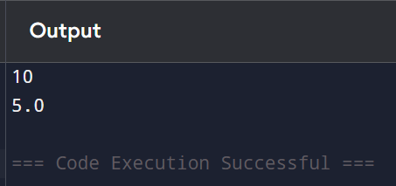
Rounding:
num = 3.756
print(round(num, 2)) # Output: 3.76

